Chapter 1 & 2 Lab

1. An example of an abstraction would be the interface we interact with on our computers, such as web interfaces and the desktop. These interfaces greatly simplify the complex coding and hardware engineering hidden under the surface and presents it as a comprehensible and interactable image that everyone can use.
2. Application programmers create programs that are directly interacted with by the end-user, while system programmers create back-end programs that are used to build/serve as the framework for application programs.

Answer: 113

Answer: 214

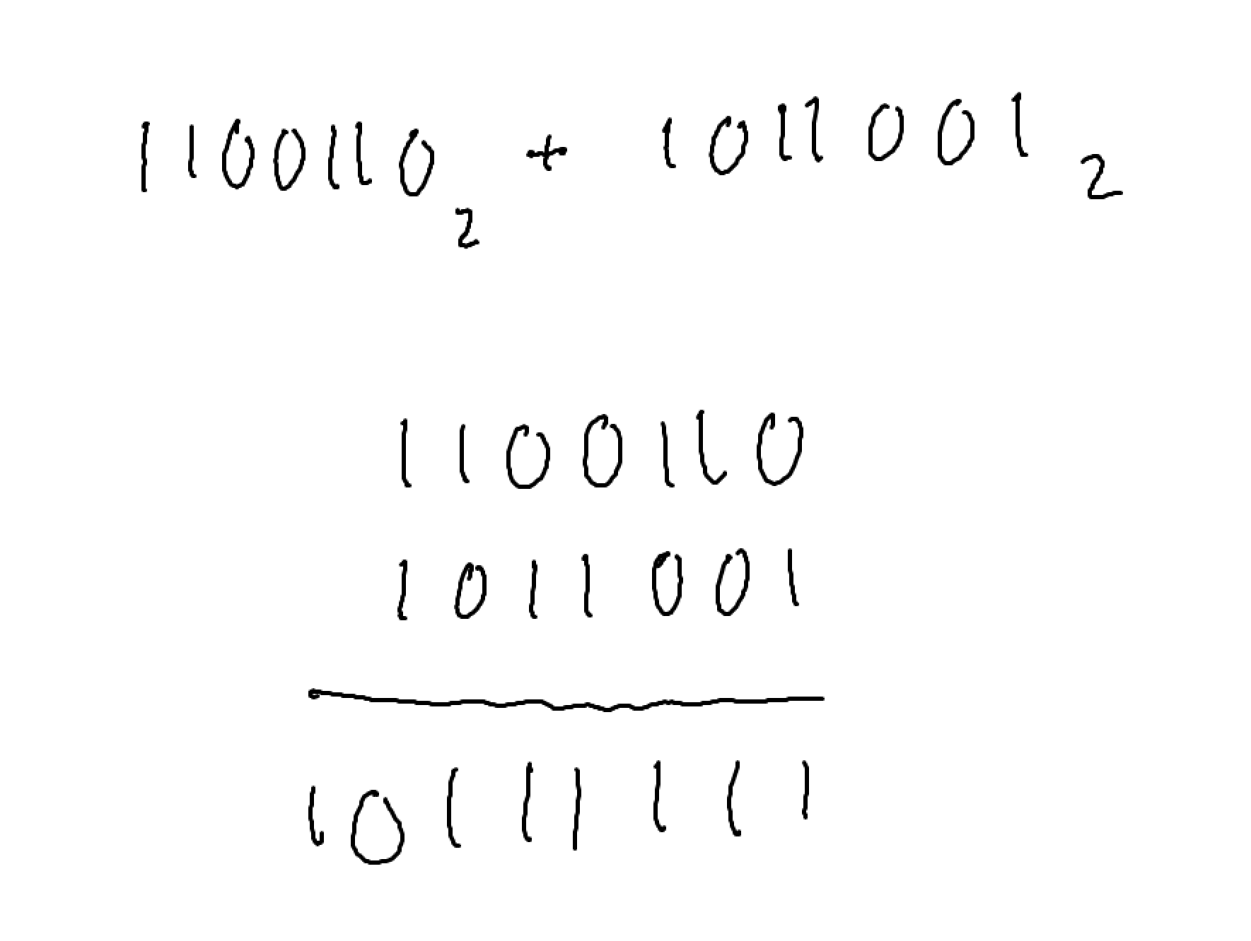Answer: 10111111

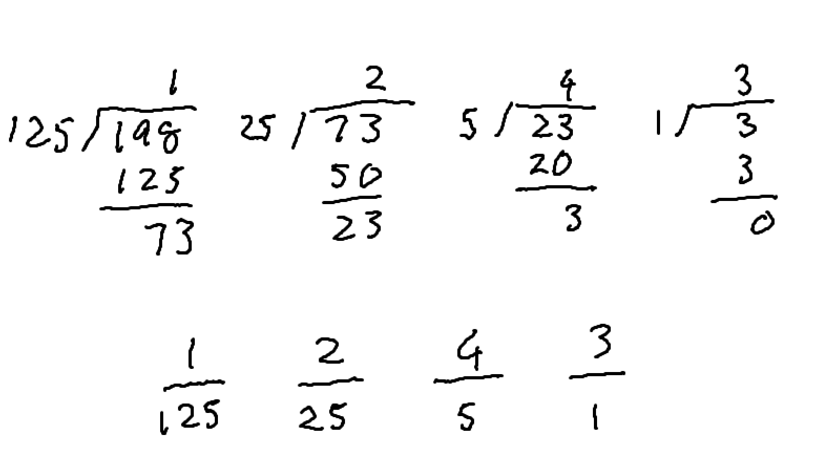

Answer: 1243

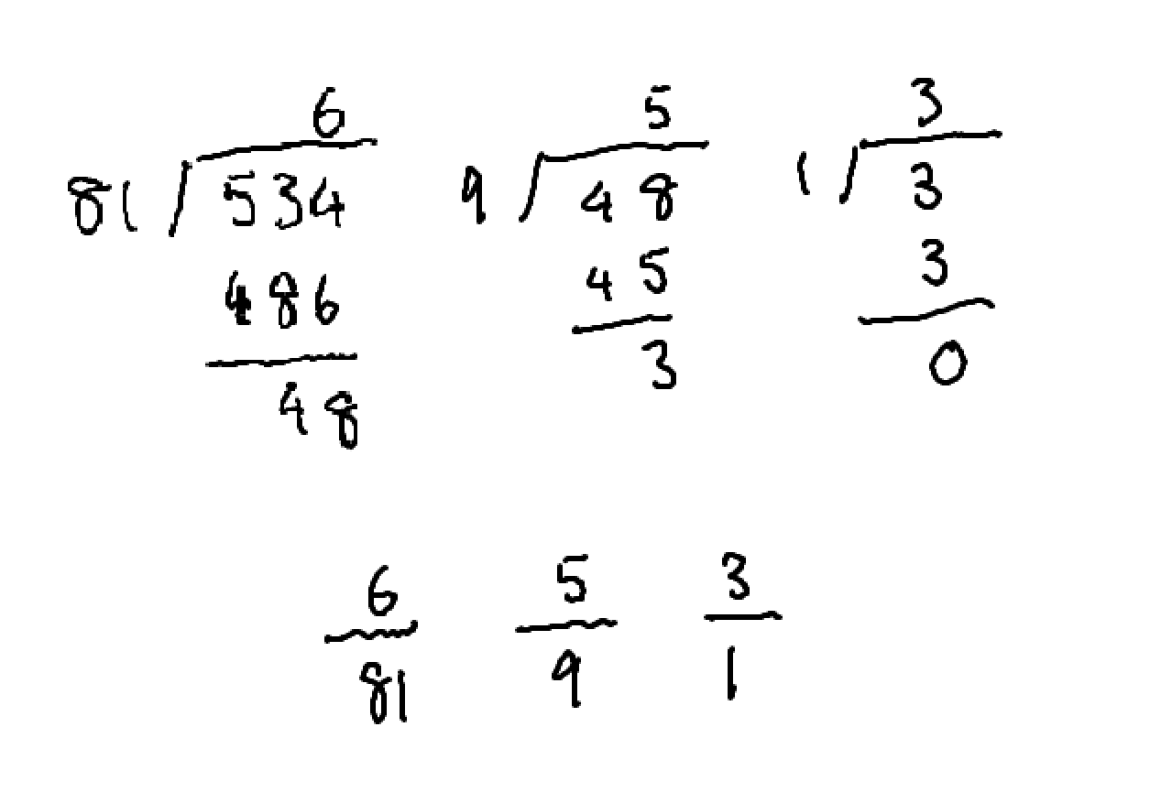Answer: 653

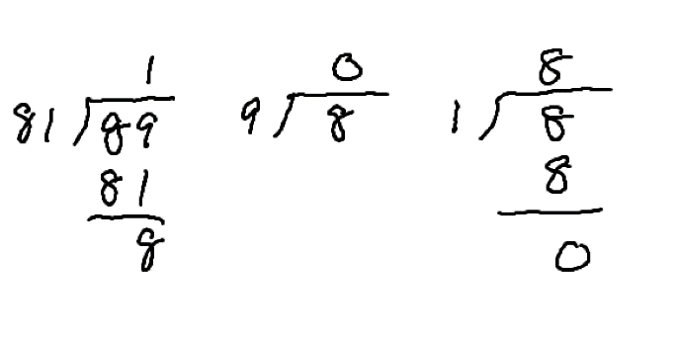

Answer: 108